### **Slide -1 Child Wellbeing Report**

Every year we produce a Child Wellbeing Report. It highlights the progress made in the past year towards improving the wellbeing of children in South Africa and in achieving specific child wellbeing ‘outcomes’ that are linked to our strategy and to global target indicators.

**Read our latest Child Wellbeing Report here [link to downloadable PDF]**

**Provided as attachments in mail-2014 report,2015 report.**

### **Slide -2 Annual Report**

Read our 2014 Annual report here **[link to downloadable PDF]**

**Yet to be provided from client**

### **Slide -3 How your money is spent**

[Graphs/infographics from WVSA AR 2014 finance pages]

**Yet to be provided from client**

### **Slide-4 Stories of Impact**

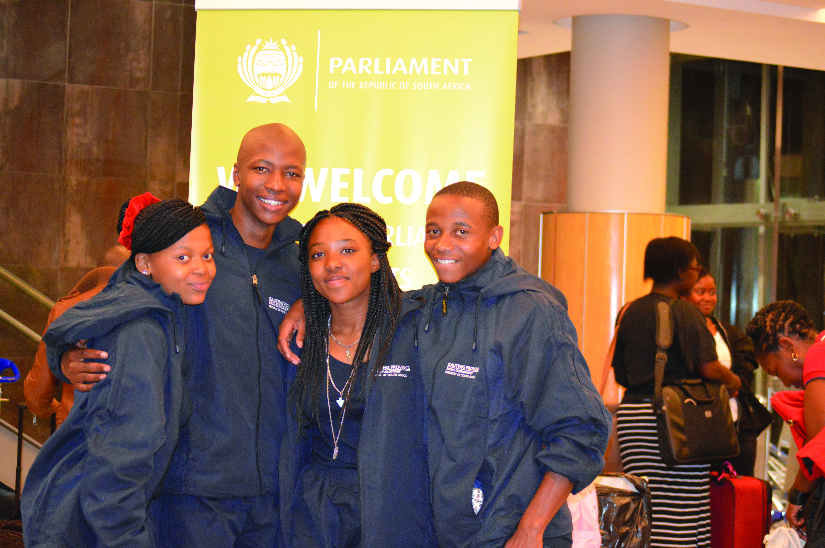

In areas of education, health, personal development, and spiritual nurturing, we are active in our in-community programmes, giving people a voice and empowering youngsters to make a difference in their own communities.

Teenager Kagiso, previously a World Vision sponsored child from Soweto, was chosen to represent the children of Gauteng at a joint sitting of the Annual Nelson Mandela Children’s Parliament in Cape Town.

He and more than 100 fellow parliamentarians aged between 11 and 17 from all nine provinces discussed issues that hinder them from enjoying their childhood. “The time is now for all of us in this beautiful land of ours to join hands and help every child enjoy being a child,” says Kagiso.

The Child Parliament is convened through a partnership between the SA Parliament, the national Department of Social Development, the Nelson Mandela Children's Fund, and World Vision.

For Minentle, 15, from KwaZulu-Natal, easy access to education for her peers in the rural areas is a constant worry. “We are appealing to government to build more schools in rural areas to ensure that children walk no more than five kilometres to school,” she pleads.

The hosting of Children's Parliament creates a platform for children's participation in democracy and provides them with an opportunity to influence policies as well as programmes and strategies intended to help them realise their rights.